**WEBSITE DESIGN AND DEVELOPMENT**

**AGREEMENT**

This Website Design and Development Agreement (the “Agreement”) is made this __28__ day of ______October__, 20_15 and is effective this upon execution of the last party to this Agreement (hereinafter referred to as the Effective Date”).

|  |  |  |  |  |  |
| --- | --- | --- | --- | --- | --- |
| **BETWEEN:** | Virtual Stacks, LLC., a Florida limited liability company (hereinafter referred to | | | | |
| as “Virtual Stacks”), with its head office located at: |  |  |  |  |
|  | 650 Technology Park |  |  |  |  |
|  | Lake Mary, Florida 32746 |  |  |  |  |
| **AND:** | **Docserve______________** (hereinafter  "Customer"), with its head office located at: | referred | to | as | the |
|  | Complete Address of Customer |  |  |  |  |
|  | Marlborough, MA. 01752_________________ |  |  |  |  |
|  | Phone: 508-787-9800 ext. 111_____________ |  |  |  |  |
|  | _____________________________________ |  |  |  |  |

# 1. BACKGROUND INFORMATION

1. Virtual Stacks is in the business of designing websites and has experience in the industry.

1. The Customer wishes to have a website created meeting the specifications (Exhibit “A”) set forth herein (“Website”) and to make such website available through the Internet.

1. The Customer is the current registered owner of the Internet domain name or will register the following Internet domain name (the Customer running the risk of the availability of its domain name to be registered):

Domain Name Address:

__http://www.docserve.com_________________________________________,

Which shall be the URL at which the Website shall be located.

**NOW THEREFORE**, in consideration of the covenants set forth herein, and for other good and valuable consideration, the receipt and sufficiency of which is hereby acknowledged, the parties agree to the following:

**2.** BACKGROUND INFORMATION

The foregoing Background Information is true and correct and is incorporated herein by this reference.

# 3. CREATION OF WEBSITE

## 3.1 Engagement of Virtual Stacks

Customer hereby engages the services of Virtual Stacks for the purpose of designing, creating, testing and delivering a fully functional Website, to be delivered to the Customer in the form of Hypertext Markup Language (“HTML”), JAVA and/or FLASH languages, most current version, which meets the specifications set forth herein and which is fully ready and operational upon placement on a server and creation of necessary connections for availability on the World Wide Web.

## 3.2 Delivery Responsibilities of the Customer

Within __Open_______ [NUMBER] days from the date of execution of this Agreement, Customer will deliver the items listed in Exhibit “B” attached hereto to Virtual Stacks. The items described in Exhibit “B” shall include all content to be included in the Website, including but not limited to textual materials, logos, photographs, sound files, databases, video files and other Website content (“Website Content”) required to be included in the Website as described in the specifications, but excluding those items that shall be the responsibility of Virtual Stacks to create as provided in Section 3.3 below. All such Website Content shall be delivered to Virtual Stacks on 100mg Zip Disc. Logo files shall be in GIF format, photographs shall be in JPG format, written text shall be in (WORD PROCESSOR) format, video files shall be in MPEG format, and sound files shall be in Mp3 file format.

## 3.3 Virtual Stacks Created Content

As provided in Section 3.2 above, the Customer shall be responsible for delivering all Website Content except for those items that Virtual Stacks has specifically agreed to create pursuant to the terms of this

Section 3.3. Virtual Stacks shall have the obligation as part of its duties hereunder to create the

Website Content listed in Exhibit “C” attached hereto. In developing the Website Content listed in Exhibit “C” hereto, Virtual Stacks is authorized to utilize such subcontractors as Virtual Stacks may elect in its sole and absolute discretion.

## 3.4 Site Plan and Site Mockup

The Website to be designed by Virtual Stacks shall be in substantial conformity with the site map and Website “mockup” attached hereto as Exhibit “D.”

## 3.5 Hidden Text

Virtual Stacks shall not include any hidden text or codes in the development of the Website except as specifically requested by the Customer. Notwithstanding the above, the Customer hereby directs Virtual Stacks to include Meta Tags on the Website which include the keywords set forth in Exhibit “E” attached hereto.

## 3.6 Placement of Site During Development

Virtual Stacks shall create a password protected access site to make the Website available for review by the Customer periodically through the development stage. Virtual Stacks will notify the Customer of the location of the Website and the method for gaining access to the Website. The password assigned to the Customer shall be unique to the Customer and shall not be provided by either party to any other party except the Customer and Virtual Stacks.

## 3.7 Stages of Completion

Virtual Stacks shall use its reasonable efforts to meet the completion schedule attached hereto in Exhibit “F.” it is contemplated by the parties that the final completion and delivery date shall be as indicated on Exhibit “F.” However, Customer acknowledges and agrees that any changes or deviations in the specifications, site plan, mockups, graphics, or any other element of the Website, and Customer delays in fulfilling Customer’s responsibilities, include delivering Site Content and promptly reviewing and commenting on completed work will lead to delays in the completion schedule.

**3.8 Form of Delivery**

The final Website shall be delivered to the Customer on 100mb Zip Disc.

## 3.9 Links

All links contained in the Website shall be tested and confirmed to be accurate prior to delivery of the final Website to the customer.

## 3.10 Acceptance Period

Customer shall have a period of ___________ [NUMBER] days following delivery of the final Website during which Customer may engage in testing of the Website. Customer shall notify Virtual Stacks no later than the ______ day following delivery of any items contained in the Website that do not conform to specifications. In the event that the Customer does not so notify Virtual Stacks within the ______ [NUMBER] day period, Customer shall be deemed to have accepted the Website in all respects.

## 3.11 Correction of Deviations From Specification

Virtual Stacks shall have a period of ____7_______ [NUMBER] days following receipt of written notification from Customer as provided in Section 2.10 above to correct any items raised by the Customer into conformance with the specifications and to deliver such corrected items to the customer. Customer shall have a period of ___7_____ [NUMBER] days after delivery of the revisions to notify Virtual Stacks of any further non-conformance with the specifications. Virtual Stacks shall have a period of ___7_____ [NUMBER] days after receipt of this notification to make corrections. This procedure shall continue until such time as Customer makes final acceptance of the Website.

**3.12 Change Orders**.

The Customer may request changes to this Agreement and the design of the Website. Such requested changes shall be only effective if made in writing and approved by Virtual Stacks with corresponding pricing approved in writing by the Customer as a condition precedent to the commencement of such change(s).

## 3.13 Back-Up Copy of Website

Virtual Stacks shall retain a backup of the Website files relative to the accepted Website for a period of _________ [NUMBER] days following final acceptance by the Customer. Thereafter, Virtual Stacks shall destroy all copies of the Customer’s Website, unless Virtual Stacks is providing hosting of the Customer’s Site pursuant to a separate hosting Agreement.

## 3.14 Delivery of Website

Following delivery of the Website to Customer it shall be Customer’s sole responsibility to run, maintain and host the Website.

## 3.15 Website Hosting

Virtual Stacks may upon request provide hosting for the Customer’s new Website at terms to be determined.

## 3.16 Website Maintenance

Virtual Stacks may upon request provide maintenance for the Customer’s new Website at terms to be determined.

# 4. COMPENSATION FOR VIRTUAL STACKS SERVICES

## 4.1 Development Fee

In consideration of the services to be performed by Virtual Stacks hereunder, including the delivery of a completed Website meeting the specifications set forth and referred to herein, the Customer shall pay to Virtual Stacks a total development fee (“Development Fee”) equal to __$2650.00______________ _______________________________ [AMOUNT], which shall be payable as set forth in the Schedule of Payment referred to in Section 4.2, below.

## 4.2 Schedule of Payments

Customer shall pay to Virtual Stacks, upon execution of this Agreement, an amount equal to ____$2650.50___________________________ [AMOUNT] as the initial payment for Virtual Stacks’ services provided hereunder. Thereafter, the remainder of the Development Fee shall be paid to the Virtual Stacks at the times described in the Schedule of Payments set forth and attached hereto as Exhibit “G.”

## 4.3 Stages of Development; Invoice

Upon achievement of the various stages of development that require an additional payment to be made to Virtual Stacks, Virtual Stacks shall notify the Customer in writing that such stage of development has been reached and shall deliver such deliverables that corresponds to that stage of development to the Customer, together with an invoice for the amount due at such stage of development. Customer shall make payment on such invoice within ___30_____ [NUMBER] days after receipt of such invoice.

## 4.4 Pass Through Expenses

The parties acknowledge and agree that all expenses associated with the development process, including but not limited to payment of any licensing fees, software procurement, costs of purchasing graphics, photographs and other web content, materials, supplies, and all other elements of the website development shall be absorbed by Virtual Stacks and that the Development Fee set forth above shall be the entire expense to be paid by the Customer hereunder. Notwithstanding the above, Customer is responsible for all costs and expenses not related to the design and development services, such as hosting, domain name registration, marketing, search engine placements, and any other service that is not described or covered by this Agreement.

## 4.5 Early Termination

In the event that this Agreement is terminated by its terms prior to completion of the Website, Virtual Stacks shall be compensated only for such work that has been completed prior to the date of termination. Upon termination hereof, Virtual Stacks shall deliver any partially completed work to the Customer on 100 Mb Zip Disc.

# 5. SEARCH ENGINE SUBMISSIONS

Included within this Development Fee payable hereunder, Virtual Stacks agrees to submit the completed

Website to, no more than __5_______ days [NUMBER], major search engines. Customer shall provide Virtual Stacks with a list of which search engines shall be included within Virtual Stacks’ services hereunder. Any additional search engine submissions shall be subject to separate agreement between the parties and shall not be included herein. Virtual Stacks and Customer shall reasonably and in good faith cooperate to optimize the results of the search engine placement. However, Virtual Stacks cannot guarantee any specific search engine placement.

7. PROPRIETARY RIGHTS TO WEBSITE

## 7.1 Creation of Website As A Work For Hire

Virtual Stacks hereby agrees that all materials that are part of the Website and that are created by Virtual Stacks, including but not limited to content, text, graphics, logos, pictures, code, scripts, algorithms, applets, audio, video and other materials (“Website Content”) shall be considered “works for hire.” As such, Customer shall be considered the exclusive owner of all proprietary rights, including but not limited to Federal Copyrights, in and to all such materials. For purposes hereof, the term “work for hire” shall have the meaning defined in the U.S. Copyright Act. Virtual Stacks acknowledges and agrees that the Customer shall have all exclusive rights in and to the Website Content that are available to the author or owner of a U.S. copyright.

## 7.2 Waiver of Common Law Rights

Virtual Stacks hereby waives, assigns and transfers onto Customer, any and all rights in and to all Website Content that may exist with respect to the Website content under any and all federal or state common law, statutory law, or otherwise, including but not limited to trade secret rights, privacy rights, moral rights, or any other right thereto.

## 7.3 Confirmatory Documents and Acts

During the term hereof and at any time thereafter, at the reasonable request and expense of the Customer, Virtual Stacks will execute further documents and take additional actions necessary to confirm or perfect the rights of the Customer in and to the Website content. This may include, but shall not be limited to executing assignments of rights, assisting in the registration of copyrights and other proprietary rights, executing waivers and certificates of originality, and any other reasonable action requested by Virtual Stacks.

## 7.4 Rights To Portions of Website Created By Independent Contractors

Customer agrees that in Virtual Stacks sole and absolute discretion independent contractors may be used by Virtual Stacks in the development process or to create any aspect of the Website Content without the written consent of the Customer. In the event that Virtual Stacks uses independent contractors, Virtual Stacks shall obtain, in advance, from each such independent contractor, an agreement assigning the proprietary rights in and to the materials that they create to the Customer.

## 7.5 Original Work

Virtual Stacks agrees that all content in the Website shall be the original creation of Virtual Stacks which is created for the sole purpose of this project, except as otherwise determined in Virtual Stacks sole and absolute discretion.

## 7.6 Copyright and Trademark

The Customer shall be solely responsible for obtaining or providing material that is or should be protect by applicable copyright or trademark protection and to obtain applicable copyright or trademark protection for Customer’s new Website.

## 7.6 Hold Harmless

Customer hereby indemnifies and holds Virtual Stacks harmless from and against all claims, suits, threats, demands, liabilities, settlements, negotiation costs and expenses, other costs, attorney fees, consequential or otherwise, whatsoever relative to any third party’s claim that the Website or any of the Website content, infringes upon or interferes with any proprietary right of such third party, including but not limited to copyrights, trademarks, trade secrets, privacy rights, moral rights, patents, publicity rights, or any other right that may now or at any time in the future exist under any federal or state law.

## 7.7 Limitation of Virtual Stacks’ Liability

CUSTOMER AGREES THAT IN THE EVENT OF ANY AND ALL DEBTS, CLAIMS, ACTIONS,

LOSSES, DAMAGES, CONTROVERSIES, ATTORNEY’S FEES, DIRECT, CONSEQUENTIAL OR

OTHERWISE, WHATSOEVER, THAT MAY ARISE FROM OR MAY BE RELATED TO THE

WEBSITE, VIRTUAL STACKS’ TOTAL LIABILITY IS LIMITED TO THE SUM ACTUALLY PAID BY CUSTOMER TO VIRTUAL STACKS FOR THE WEBSITE AND ACCORDINGLY CUSTOMER SHALL HOLD VIRTUAL STACKS HARMLESS.

## 7.8 License To Virtual Stacks of Certain Portions

Customer hereby grants to Virtual Stacks the perpetual, non-exclusive, royalty free, worldwide license to use certain of the Website Content described in Exhibit “H” attached hereto. This license is personal to Virtual Stacks and may not be assigned or sublicensed without the consent of the Customer, except that Virtual Stacks may grant a limited license to its future customers if any of the licensed items are included in any website that is created by Virtual Stacks in the future. The license granted herein does not extend to any identifying material of the business name or trademarks of the Customer.

# 8. VIRTUAL STACKS REPRESENTATIONS AND WARRANTIES

Virtual Stacks makes the following representations and warranties to the Customer:

## 8.1 Full power

Virtual Stacks has full and unrestricted power and authority to enter into this Agreement and to grant the exclusive rights in and toe all Website content to the Customer.

## 8.2 Sole and exclusive creator

Virtual Stacks is the sole and exclusive creator of the Website Content and has not created any such materials as a joint work with any other party, through independent contractors, or in any other way that would give any other party any rights in and to the Website Content except as otherwise provided for in this Agreement.

## 8.3 No pre-existing work

That there are no pre-existing work integrate into the Website Content that have not been disclosed to the Customer and for which Virtual Stacks has not obtained a valid license complying with the terms of this Agreement which permits the Customer to exclusively use the Pre-existing Work.

## 8.4 No liens and infringement

There are no liens, encumbrances or security interests of any nature or kind affecting the Website. None of the Website content infringes upon the proprietary rights of any third party.

## 8.5 Conformity with latest versions

The Website will perform to all specifications and will have cross-platform uniformity in that it will function in the latest versions of the Microsoft Internet Explorer and Netscape browsers.

## 8.6 Disclaimer

VIRTUAL STACKS DOES NOT WARRANT THAT THE FUNCTIONS CONTAINED IN ITS WEB

PAGES OR THE WEBSITE WILL MEET THE CUSTOMER'S EXPECTATION OR REQUIREMENTS

OR THAT THE OPERATION OF THE WEB PAGES OR WEBSITE WILL BE UNINTERRUPTED OR

ERROR-FREE. THE ENTIRE RISK AS TO THE QUALITY AND PERFORMANCE OF THE WEB

PAGES AND WEBSITE IS WITH CUSTOMER. EXCEPT AS OTHERWISE SPECIFIED IN THIS AGREEMENT, VIRTUAL STACKS PROVIDES ITS SERVICES "AS IS" AND WITHOUT WARRANTY

OF ANY KIND. THE PARTIES AGREE THAT (A) THE LIMITED WARRANTIES SET FORTH IN THIS SECTION ARE THE SOLE AND EXCLUSIVE WARRANTIES PROVIDED BY EACH PARTY, AND (B)

EACH PARTY DISCLAIMS ALL OTHER WARRANTIES, EXPRESS OR IMPLIED, INCLUDING BUT

NOT LIMITED TO, THE IMPLIED WARRANTIES OF MERCHANTABILITY AND FITNESS FOR A

PARTICULAR PURPOSE, RELATING TO THIS AGREEMENT, PERFORMANCE, FUNCTIONALITY

OR INABILITY TO PERFORM UNDER THIS AGREEMENT, THE CONTENT, AND EACH PARTY'S

COMPUTING AND DISTRIBUTION SYSTEM. IF ANY PROVISION OF THIS AGREEMENT SHALL

BE UNLAWFUL, VOID, OR FOR ANY REASON UNENFORCEABLE, THEN THAT PROVISION SHALL BE DEEMED SEVERABLE FROM THIS AGREEMENT AND SHALL NOT AFFECT THE VALIDITY AND ENFORCEABILITY OF ANY REMAINING PROVISIONS.

# 9. CONFIDENTIALITY COVENANTS

1. The parties acknowledge and agree that during the course of the relationship contemplated hereby that they are likely to come into contact and gain knowledge and access to information and materials that the other party deems to be confidential, proprietary or of strategic importance. The parties each agree that they shall maintain the strictest confidentiality of all such materials that they receive concerning the other party hereto. They shall not disclose such confidential information to any other party, shall not use such confidential information for their own purposes, and they shall protect such confidential information from disclose using the same or higher standards as they use to protect their own confidential information.

1. The parties agree that confidential information shall be limited to disclosure within the organization of the recipient to those top management personnel and Virtual Stacks with a bona fide need to know such information as a necessary part of their contribution to the performance under this Agreement.

1. For purposes of this Agreement, confidential information shall include any and all information that is of a proprietary, confidential or trade secret nature, of strategic importance, or is otherwise considered to be confidential or proprietary by the releasing party. Confidential information will include items such as business plans, marketing plans and strategies, formula, processes, data, software source codes, financial information, customer lists, and all other information deemed confidential by the parties. Confidential information shall not include items that are generally available to the public, generally known in the industry, exist in the public domain, is learned from an outside source independent from the relationship established by this Agreement or was known prior to the entering of this Agreement.

# 10. TERM AND TERMINATION

1. This Agreement shall commence on the effective date hereof and shall remain in effect until the earlier of the completion of all services called for hereunder to be performed by Virtual Stacks, or the earlier termination of this Agreement as provided in this Article IX.

1. This Agreement may be terminated by the customer, with or without cause, by giving 30_________ [NUMBER] business days written notice of such termination to Virtual Stacks.

1. Customer may terminate this Agreement immediately upon written notice to Virtual Stacks in the event that Virtual Stacks substantially breaches or defaults under any of Virtual Stacks’ obligations contained in this Agreement or if Virtual Stacks is unable to or refuses to perform services hereunder.

1. Upon the effective date of any termination of this Agreement, all legal obligation, rights and duties arising out of this Agreement shall terminate except that: (i) Customer shall remain obligated to

pay any balance due to Virtual Stacks for services provided hereunder: (ii) the Confidentiality Restrictions, Ownership of Proprietary Rights Provisions, and Independent Contractor provisions of this Agreement shall continue to apply and shall survive the termination of this Agreement as ongoing covenants between the parties; (iii) Virtual Stacks shall have the continuing obligation to return to the Customer all tangible and intangible property of the customer and all versions of any Proprietary Products of the customer or developed for the Customer during the effectiveness of this Agreement; and (iv) Virtual Stacks shall have the ongoing duty and obligation to confirm in writing and take all reasonable steps to secure proprietary right in the Proprietary Products developed pursuant to this Agreement in the name and exclusive ownership of the Customer.

# 11. NOTICES

Any notification or written communication required by or contemplated under the terms of this Agreement shall be in writing and shall deemed to be delivered if transmitted via Email at the Email addresses listed below, except for any notice of termination of this Agreement which shall be in writing and sent by U.S. Mail, Certified Mail, Return Receipt Requested to the addresses stated in section 1 and shall be deemed to have been delivered five (5) business days after the date of mailing. Email addresses for such notices shall be:

If to Virtual Stacks: info@virtualstacks.com [EMAIL ADDRESS]

If to Customer: [bassam@metrovista.com](mailto:bassam@metrovista.com) [EMAIL ADDRESS]

# 12. NO ASSIGNMENT

The Customer may not assign this Agreement to any third party without the prior express written approval of Virtual Stacks which may be withheld.

# 13. BINDING EFFECT

This agreement shall bind and inure to the benefit of the successors, assigns, personal representatives and heirs of the Parties hereto.

# 14. INDEPENDENT CONTRACTOR STATUS

The parties agree that Virtual Stacks shall be an independent contractor and not an agent, employee, partner or representative of Customer. Customer shall have no right to direct or control the details of Virtual Stacks’ work. Virtual Stacks shall not receive any fringe benefits or other perquisites that the Customer may provide to its employees and Virtual Stacks agrees to be responsible for its own business overhead and costs of doing business and to furnish (or reimburse Customer for) all tools and materials necessary to accomplish the services required of Virtual Stacks pursuant to this Agreement, and shall incur all expenses associated with performance, except as expressly provided in Exhibits or amendments to this Agreement. Virtual Stacks shall be responsible for paying all taxes on payments received pursuant to this Agreement and that Customer shall have no obligation to withhold taxes from service fees payable to Virtual Stacks hereunder. Virtual Stacks hereby indemnifies and holds the customer harmless any obligation that may be imposed on Customer (i) to pay in withholding taxes or similar items or (ii) resulting from Virtual Stacks' being determined not to be an independent contractor.

# 15. DISPUTES

The Parties agree to take all steps possible to make a good-faith efforts to resolve any disagreements or disputes arising out of, or in connection with, this Agreement through negotiation. The Parties shall have thirty (30) days as a condition precedent to so resolve any disagreements or disputes prior to filing suit.

# 16. INTERPRETATION OF AGREEMENT

The parties acknowledge that this Agreement is the product of mutual efforts by the parties and their respective agents. This Agreement shall be interpreted neither more favorably in favor of one party, nor less favorably in favor of another party.

# 17. GOVERNING LAW

This Agreement shall be governed solely by the laws of the State of Florida (without regard to the laws that might be applicable under principles of conflicts of law) as to all matters, including, but not limited to, matters of validity, construction, effect and performance.

# 18. VENUE AND JURISDICTION

Should a lawsuit be necessary to enforce this Agreement, resolve any disagreements or disputes, the parties agree that jurisdiction and venue are waived and suit shall be brought in the state court in Miami-Dade County, Florida.

# 19. ENTIRE AGREEMENT

This Agreement contains the entire agreement and understanding of the parties with respect to the subject matter hereof and supersedes and replaces all prior discussions, agreements, proposals, understandings, whether orally or in writing, between the parties related to the subject matter of this Agreement. This Agreement may be changed, modified or amended only in a written agreement that is duly executed by authorized representatives of the parties. If any provisions hereof are deemed to be illegal or unenforceable by a court of competent jurisdiction, the enforceability of effectiveness of the remainder of the Agreement shall not be effected and this Agreement shall be enforceable without reference to the unenforceable provision. No party’s waiver of any breach or accommodation to the other party shall be deemed to be a waiver of any subsequent breach.

# 20. SURVIVABILITY OF AGREEMENT

The Parties hereto acknowledge that this agreement shall survive the Closing of this transaction as to the terms and conditions herein.

# 21. TIME OF THE ESSENCE

Both Parties recognize that time is of the essence in this Agreement and that the failure to develop, test and deliver the deliverables hereunder in accordance with the Delivery Schedule shall result in expense and irreparable damage to the Customer.

**22. FORCE MAJEURE**

Neither Party shall be deemed in default of this Agreement to the extent that performance of its obligations or attempts to cure any breach are delayed, restricted or prevented by reason of any act of God, fire, natural disaster, act of government, strikes or labor disputes, inability to provide raw materials, power or supplies, or any other act or condition beyond the reasonable control of the party in question.

# 23. PARTIAL INVALIDITY

Should any provision of this Agreement be held to be void, invalid or inoperative, the remaining provisions of this Agreement shall not be affected and shall continue in effect and the invalid provision shall be deemed modified to the least degree necessary to remedy such invalidity?

# 24. NO WAIVER

The failure of either Party to partially or fully exercise any right or the waiver by either party of any breach, shall not prevent a subsequent exercise of such right or be deemed a waiver of any subsequent breach of the same or any other term of this Agreement.

# 25. HEADINGS

The section headings contained in this Agreement are for reference purposes only and shall not in any way affect the meaning or interpretation of this Agreement.

**26. COUNTERPARTS**

This Agreement may be executed in counterparts, and each of which shall be deemed an original and all of which together shall constitute one and the same document

IN WITNESS WHEREOF, the parties hereto have duly entered and executed this Agreement as of the day and year first above written and represent and warrant that the party executing this Agreement on their behalf is duly authorized.

VIRTUAL STACKS CUSTOMER

Authorized Signature Authorized Signature

Print Name and Title Print Name and Title

**EXHIBIT “A” WORKFLOW OVERVIEW**

eServe will provide storefront environments for multiple clients from its XMPie AWS environment with individual storage arrays in AWS for each storefront, ***Example*** (*PTC store front will be attached to PTC Storage array*). In stage one eServe will predetermine which clients will receive the PDFTRON viewer experience by pre converting the client files to the XOD file format and place them in the appropriate directory for viewing.

The custom process or integration point will be triggered when the client selects download from within the exmpie storefront environment at this point the process will check the appropriate storage array for XOD files and the PDFTRON viewer will be launched only if XOD files are present in the particular client’s storage array if no XOD files are present the viewer will not be launched.

Please note it is important to understand the process will be looking for the most up to date XOD file based on the fact the clients could possibly annotate the content they are downloading. During our call last week Ramon raised a critical point regarding how will the client navigate back to the content at this point we will be relying on the standard xmpie storefront order history cart.

**EXHIBIT “B” FILE FORMATS**

Emag ebooks, PDFs, word, Excel, Power Point Note: I have documented the file formats here based on this point came up in our discussion last week this will be more relevant in the future if we move to an on demand/on the file XOD file conversion process but it is worth noting to ensure the architecture will support this.

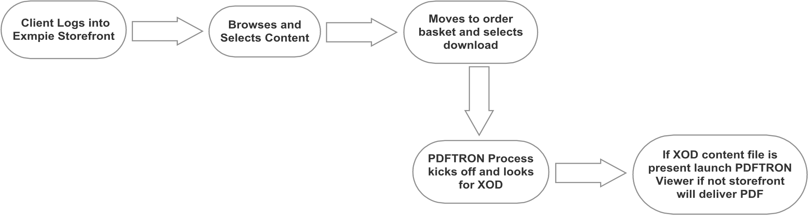

**EXHIBIT “C”**

**Exmpie Storefront Order Flow Pictorial**

1. **Storefront Product Selection (Skinned Presentation of Storefront)**

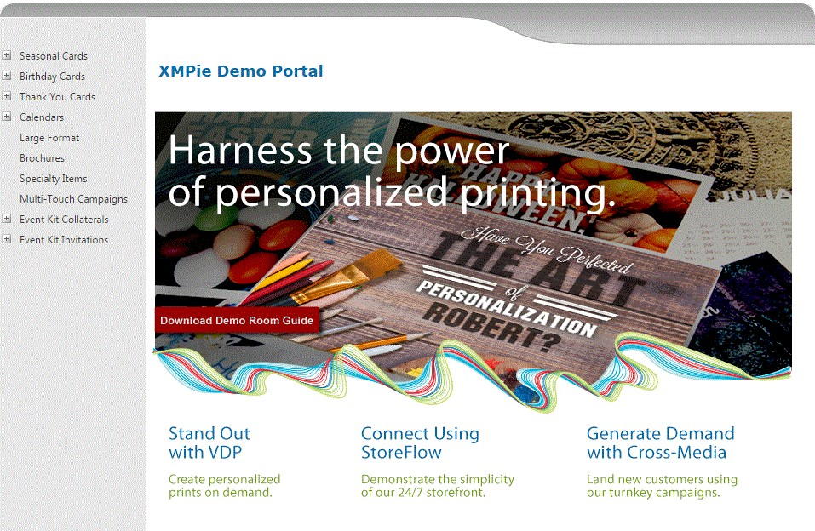

1. **Product Selection and Customization**

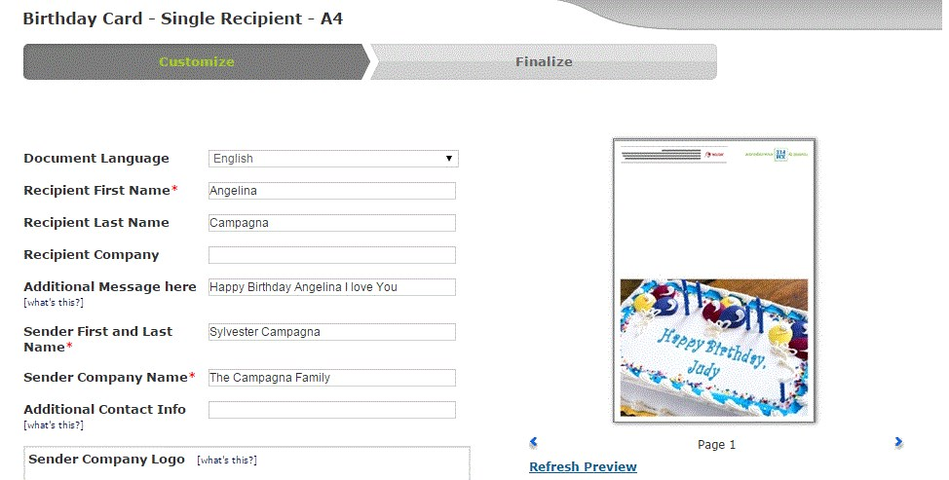

1. **Proof of Product Selection**

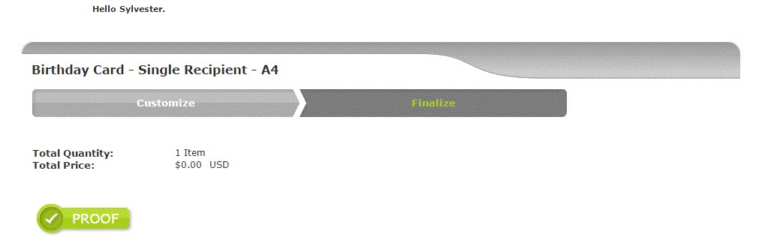

**EXHIBIT “D”**

**Exmpie Storefront Order Flow Pictorial Cont.**

1. **Content Shopping Cart**

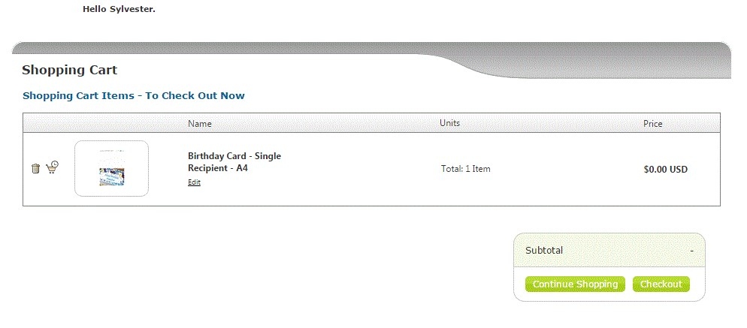

1. **Order details and download ( Note this is where the PDFTRON process will kick off)**

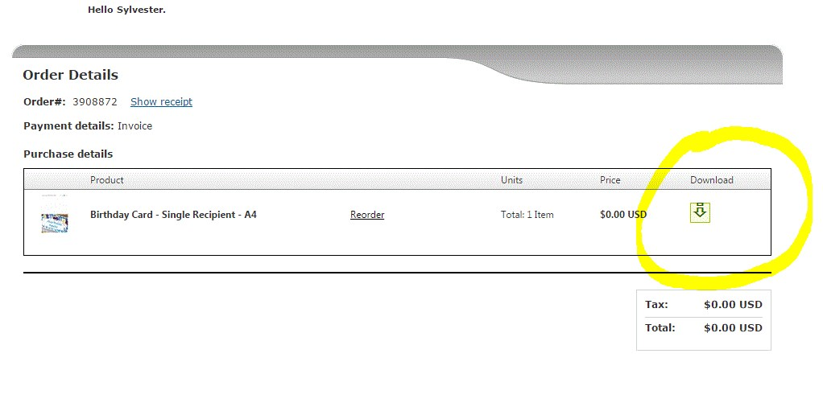

1. **My Account**

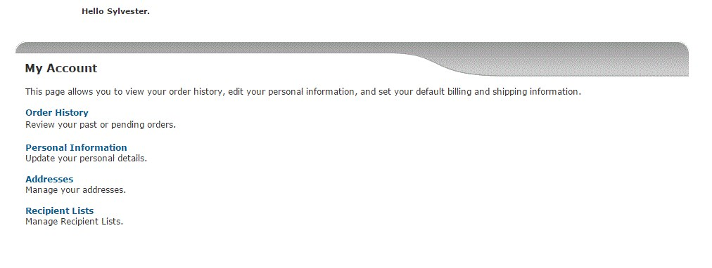

**EXHIBIT “E”**

**Exmpie Storefront Order Flow Pictorial Cont.**

1. **My Order History**

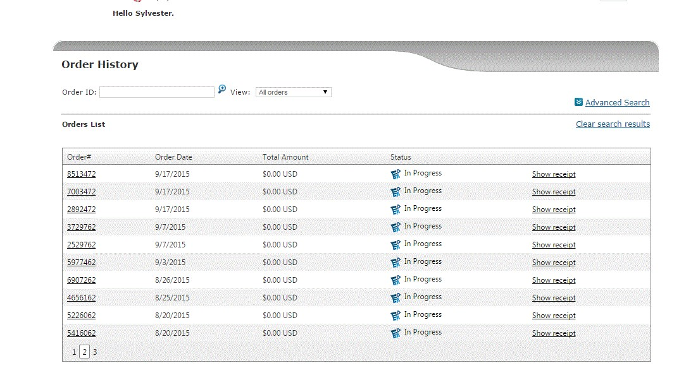

1. Order details (After selecting one of the orders from above it will take you back to the download mechanism)

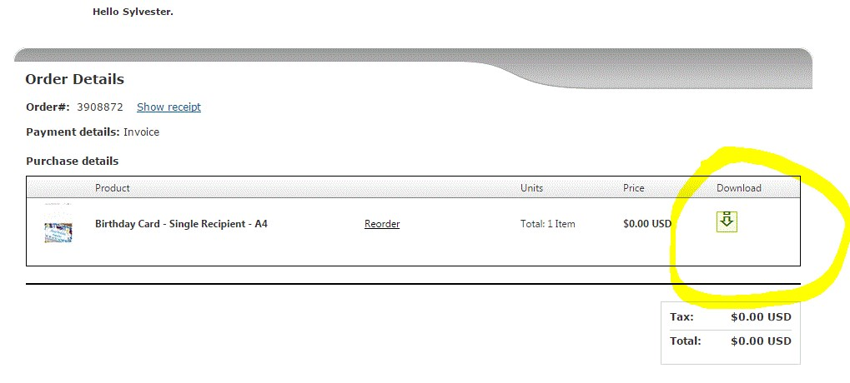

**EXHIBIT “F” SCHEDULE OF COMPLETION**

**Three Weeks from Execution Date**

**EXHIBIT “G”**

**PAYMENT SCHEDULE**

1. **Purchase** **Price**. The purchase price for the Website shall be a total sum of $___2650.00__ and, however, may be increased due to CUSTOMER’s change orders.

1. **Payment** **Schedule**. Seller and Buyer have agreed to the following payment schedule for the Buyer to be paid in U.S., as follows for the Asset:

* 1. $___2650.00__ Due Date: _Pre Determined Terms_

* 1. $____________ Due Date: ______________

* 1. $____________ Due Date: ______________

* 1. $____________ Due Date: ______________